EXPERIMENT 1: DDL Commands – CREATE, ALTER, DROP

CREATE DATABASE labdb;
USE labdb;
CREATE TABLE student2 (RegNo INT, SIName VARCHAR(15), Age CHAR(2), MobileNo INT, address VARCHAR(15));
ALTER TABLE student2 ADD PRIMARY KEY(RegNo);
DESC student2;
CREATE TABLE faculty (Facno INT, FName CHAR(15), gender CHAR(1), DOB DATE, MobileNo INT, address VARCHAR(20));
ALTER TABLE faculty ADD PRIMARY KEY(Facno);
ALTER TABLE faculty ADD CHECK (gender IN ('M','F'));
DESC faculty;
CREATE TABLE department (deptno INT, dname CHAR(15), loc CHAR(10));
ALTER TABLE department ADD PRIMARY KEY(deptno);
DESC department;
CREATE TABLE course (cno INT, cname VARCHAR(15), semno INT, facno INT);
ALTER TABLE course ADD PRIMARY KEY(cno);
ALTER TABLE course ADD CHECK (semno >=1 AND semno <=6);
DESC course;
ALTER TABLE student2 ADD UNIQUE KEY(SIName);
DESC student2;
ALTER TABLE student2 MODIFY address VARCHAR(15) NOT NULL;
DESC student2;
SHOW TABLES;

OUTPUT:

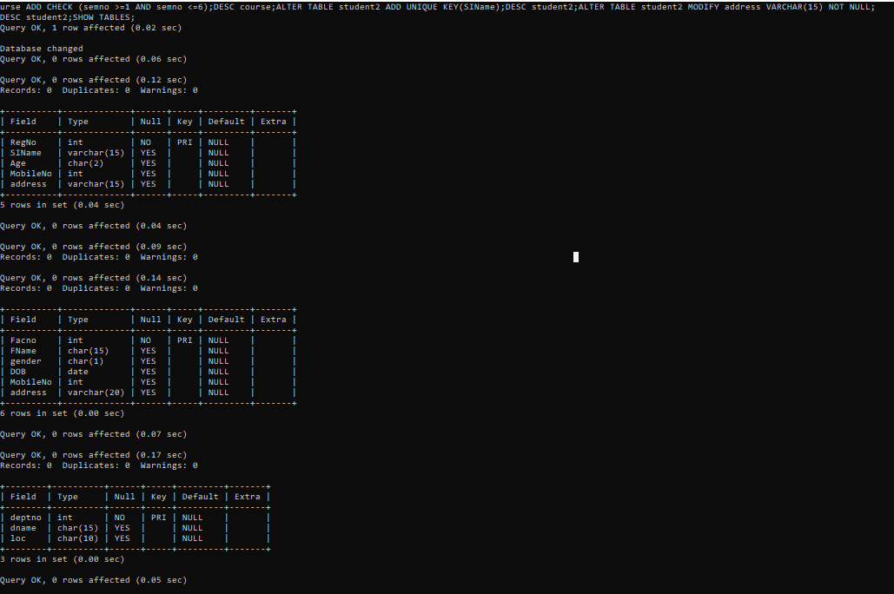
EXPERIMENT2: DDL Commands with Constraints – PRIMARY,
FOREIGN KEY, UNIQUE, CHECK

CREATE DATABASE labdb2;
USE labdb2;
CREATE TABLE department (DeptNo INT PRIMARY KEY, DName VARCHAR(20) UNIQUE, Location VARCHAR(15));
DESC department;
CREATE TABLE faculty (FacNo INT PRIMARY KEY, FName VARCHAR(20), Gender CHAR(1) CHECK (Gender IN ('M','F')), DeptNo INT, FOREIGN KEY (DeptNo) REFERENCES department(DeptNo));
DESC faculty;
CREATE TABLE course (CNo INT PRIMARY KEY, CName VARCHAR(20) UNIQUE, SemNo INT CHECK (SemNo BETWEEN 1 AND 6), FacNo INT, FOREIGN KEY (FacNo) REFERENCES faculty(FacNo));
DESC course;
CREATE TABLE student (RegNo INT PRIMARY KEY, SName VARCHAR(20) UNIQUE, Age INT CHECK (Age>=18), DeptNo INT, FOREIGN KEY (DeptNo) REFERENCES department(DeptNo));
DESC student;
SHOW TABLES;
OUTPUT:
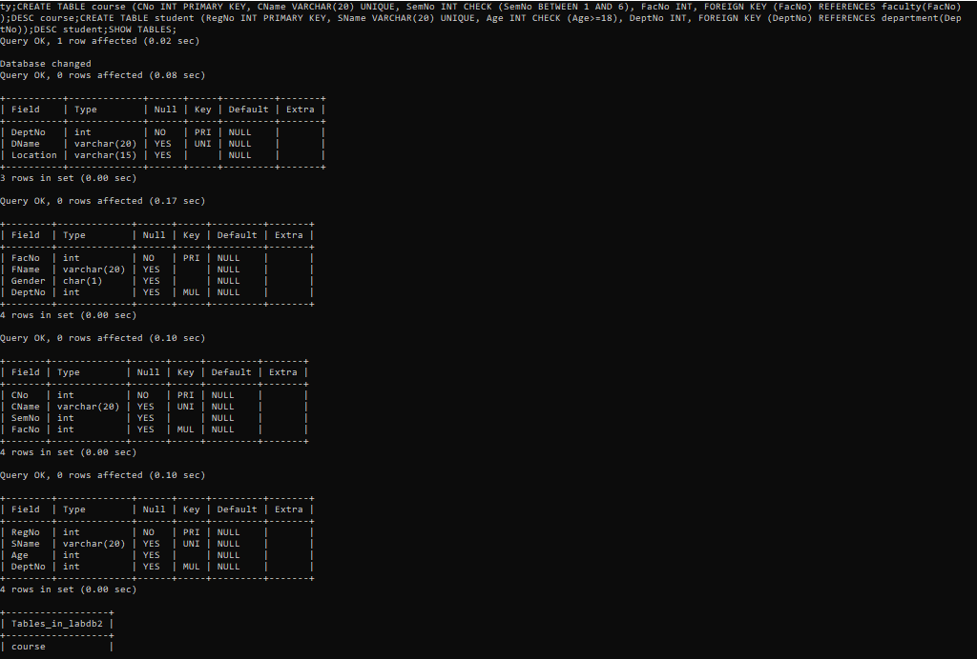
EXPERIMENT3: DML Commands – INSERT, SELECT, UPDATE, DELETE
CREATE DATABASE lab3;
USE lab3;
CREATE TABLE department(
deptno INT PRIMARY KEY,
dname VARCHAR(20),
hod VARCHAR(20)
);
CREATE TABLE faculty(
facno INT PRIMARY KEY,
fname VARCHAR(20),
gender CHAR(1),
mobileno BIGINT,
doj DATE,
deptno INT,
FOREIGN KEY (deptno) REFERENCES department(deptno)
);
CREATE TABLE student2(
RegNo INT PRIMARY KEY,
SName VARCHAR(20),
Age INT,
MobileNo BIGINT,
Facno INT,
FOREIGN KEY (Facno) REFERENCES faculty(facno)
);
INSERT INTO department VALUES
(1,'CSE','Ravi'),
(2,'ECE','Sita');
SELECT * FROM department;
INSERT INTO faculty VALUES
(101,'Anil','M',9876543210,'2020-06-01',1),
(102,'Kavya','F',9876501234,'2021-01-10',2);
SELECT * FROM faculty;
INSERT INTO student2 VALUES
(1,'Manoj',20,9876500001,101),
(2,'Ramesh',21,9876500002,102);
SELECT * FROM student2;
UPDATE student2 SET Age=22 WHERE RegNo=1;
SELECT * FROM student2;
DELETE FROM student2 WHERE RegNo=2;
SELECT * FROM student2;

OUTPUT

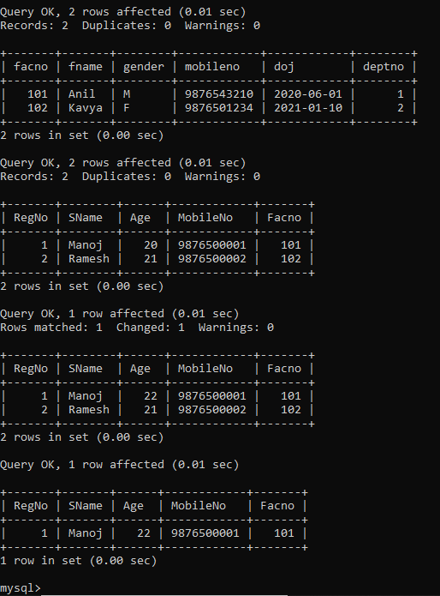

EXPERIMENT 4: SELECT with various clause – WHERE, pattern matching
CREATE DATABASE lab4;
USE lab4;
CREATE TABLE student(
RegNo INT,
SName VARCHAR(20),
Age INT,
Branch VARCHAR(10)
);
INSERT INTO student VALUES
(1,'Ravi',20,'CSE'),
(2,'Kavya',21,'ECE'),
(3,'Ramesh',22,'CSE'),
(4,'Manoj',20,'EEE'),
(5,'Sita',21,'CSE');
-- Queries
SELECT * FROM student;
SELECT * FROM student WHERE Age=20;
SELECT * FROM student WHERE Branch='CSE';
SELECT * FROM student WHERE Age>20;
SELECT * FROM student WHERE Branch!='ECE';
SELECT * FROM student WHERE SName LIKE 'R%';
SELECT * FROM student WHERE SName LIKE '%a';
SELECT * FROM student WHERE SName LIKE '_a%';
SELECT * FROM student WHERE Branch IN ('CSE','EEE');
SELECT * FROM student WHERE Age BETWEEN 20 AND 21;

OUTPUT:
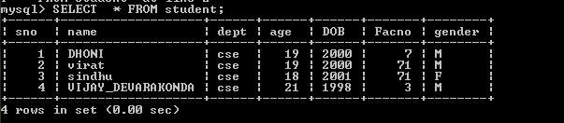

2)
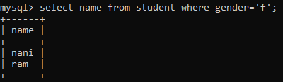

3)
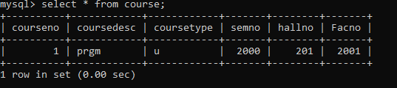
4)
5)
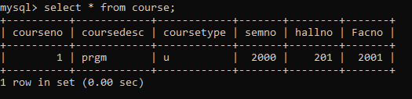

EXPERIMENT 5: SELECT with various clause – BETWEEN, IN, Aggregate function

CREATE DATABASE lab5;
USE lab5;
CREATE TABLE employee(
EmpNo INT,
EName VARCHAR(20),
Salary INT,
DeptNo INT
);
INSERT INTO employee VALUES
(1,'Ravi',30000,10),
(2,'Kavya',40000,20),
(3,'Manoj',25000,10),
(4,'Sita',50000,30),
(5,'Ramesh',45000,20);
-- Queries
SELECT * FROM employee;
SELECT * FROM employee WHERE Salary BETWEEN 30000 AND 50000;
SELECT * FROM employee WHERE DeptNo IN (10,30);
SELECT COUNT(*) FROM employee;
SELECT MAX(Salary) FROM employee;
SELECT MIN(Salary) FROM employee;
SELECT AVG(Salary) FROM employee;
SELECT SUM(Salary) FROM employee;

OUTPUT:
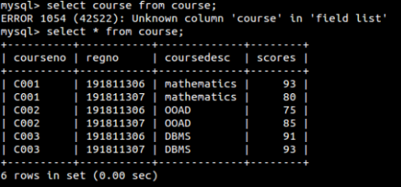
2)
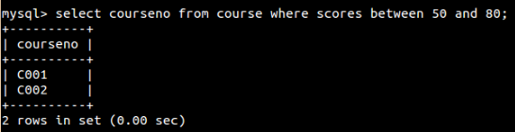
1)
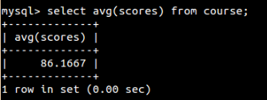
2)
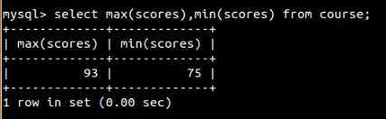

EXPERIMENT 6: SELECT with various clause – GROUP BY, HAVING, ORDER BY
CREATE DATABASE lab6;
USE lab6;
CREATE TABLE sales(
SaleID INT,
Product VARCHAR(20),
Quantity INT,
Price INT
);
INSERT INTO sales VALUES
(1,'Pen',10,5),
(2,'Book',5,50),
(3,'Pen',20,5),
(4,'Pencil',15,3),
(5,'Book',10,50),
(6,'Pen',5,5);
-- Queries
SELECT * FROM sales;
SELECT Product, SUM(Quantity) FROM sales GROUP BY Product;
SELECT Product, SUM(Quantity) FROM sales GROUP BY Product HAVING SUM(Quantity) > 15;
SELECT * FROM sales ORDER BY Product;
SELECT * FROM sales ORDER BY Price DESC;

OUTPUT:
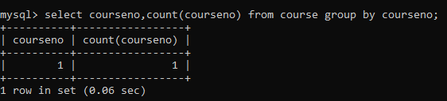
2)
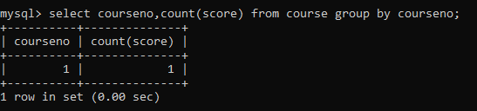
3)
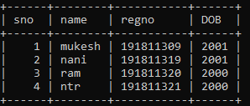

4)
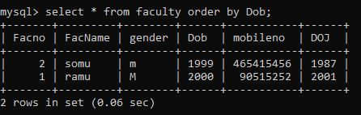

EXPERIMENT7: SubQuery& Correlated Query
CREATE DATABASE lab7;
USE lab7;
CREATE TABLE student(
SID INT,
SName VARCHAR(20),
Marks INT
);
INSERT INTO student VALUES
(1,'Ravi',85),
(2,'Kavya',92),
(3,'Manoj',76),
(4,'Sita',89);
SELECT * FROM student;
-- Subquery: Highest marks
SELECT SName, Marks
FROM student
WHERE Marks = (SELECT MAX(Marks) FROM student);
-- Correlated Query: Marks greater than overall average
SELECT S1.SName, S1.Marks
FROM student S1
WHERE S1.Marks > (
SELECT AVG(S2.Marks) FROM student S2
);

OUTPUT:
1) Which of the student’s score is greater than the avg score?

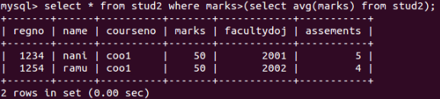
2) Which of the students’ have written more than one assessment test?

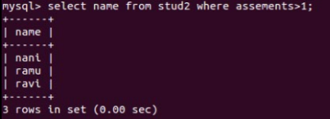
3) Which faculty has joined recently and when?

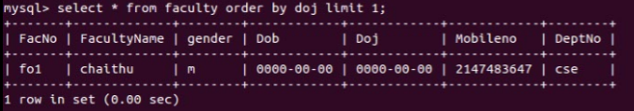
4) List the course and score of assessments that have the value more than the average score each Course

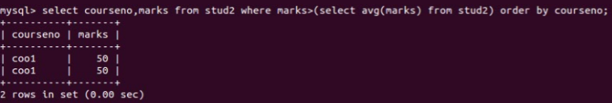

EXPERIMENT 8: Joins – EquiJoin, InnerJoin, OuterJoin
CREATE DATABASE lab8;
USE lab8;
CREATE TABLE dept(
DeptNo INT,
DeptName VARCHAR(20)
);
INSERT INTO dept VALUES
(10,'CSE'),
(20,'ECE'),
(30,'EEE');
CREATE TABLE employee(
EmpNo INT,
EName VARCHAR(20),
DeptNo INT
);
INSERT INTO employee VALUES
(1,'Ravi',10),
(2,'Kavya',20),
(3,'Manoj',10),
(4,'Sita',40);
-- View all rows
SELECT * FROM dept;
SELECT * FROM employee;
-- Joins
SELECT e.EmpNo, e.EName, d.DeptName
FROM employee e, dept d
WHERE e.DeptNo = d.DeptNo;
SELECT e.EmpNo, e.EName, d.DeptName
FROM employee e
INNER JOIN dept d ON e.DeptNo = d.DeptNo;

SELECT e.EmpNo, e.EName, d.DeptName
FROM employee e
LEFT JOIN dept d ON e.DeptNo = d.DeptNo;
SELECT e.EmpNo, e.EName, d.DeptName
FROM employee e
RIGHT JOIN dept d ON e.DeptNo = d.DeptNo;
OUTPUT:
- List the departments where the faculty members are working.
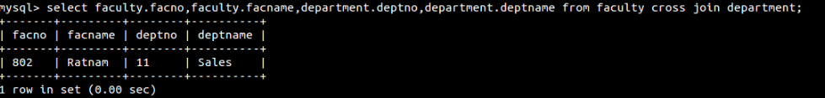
- Find the student who has no score in any of the courses. List student name and course number.

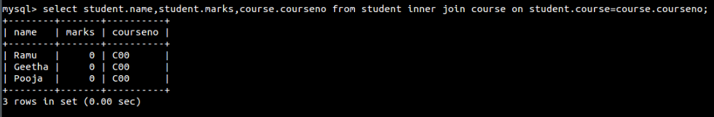
3) The office clerk needs the names of the courses taken by the faculty belonging to ‘Sales’ whose name is ‘Ratnam’
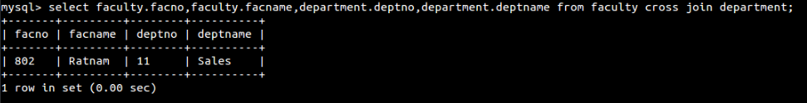

EXPERIMENT 9: VIEW, INDEX, SEQUENCE
-- Create a sample database
CREATE DATABASE companyDB;
USE companyDB;
-- Create an employees table
CREATE TABLE employees (
EmpID INT PRIMARY KEY,
EmpName VARCHAR(50),
DeptName VARCHAR(30),
Salary INT
);
-- Insert some sample records
INSERT INTO employees VALUES
(1, 'Ravi', 'IT', 50000),
(2, 'Kavya', 'IT', 60000),
(3, 'Arun', 'HR', 40000),
(4, 'Divya', 'HR', 45000),
(5, 'Sita', 'Finance', 70000),
(6, 'Raj', 'Finance', 80000),
(7, 'Mohan', 'IT', 55000);
-- Example 1: GROUP BY (average salary by department)
SELECT DeptName, AVG(Salary) AS Avg_Salary
FROM employees
GROUP BY DeptName
-- Example 2: GROUP BY with HAVING (departments with average salary > 55000)
SELECT DeptName, AVG(Salary) AS Avg_Salary
FROM employees
GROUP BY DeptName
HAVING AVG(Salary) > 55000;

-- Example 3: GROUP BY + HAVING + ORDER BY (highest average salaries first)
SELECT DeptName, AVG(Salary) AS Avg_Salary
FROM employees
GROUP BY DeptName
HAVING AVG(Salary) > 45000
ORDER BY Avg_Salary DESC;

OUTPUT:
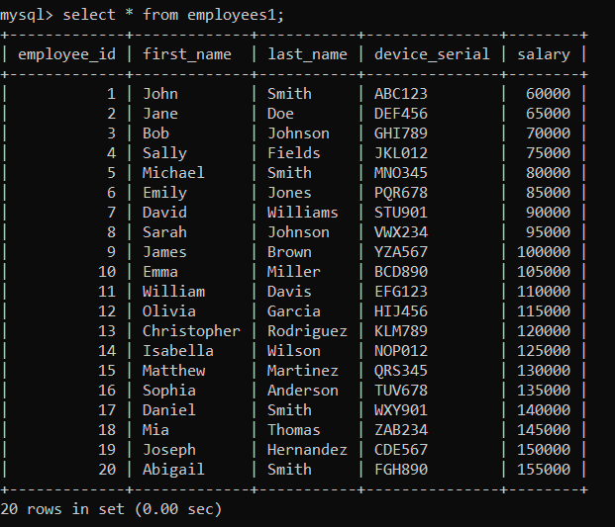

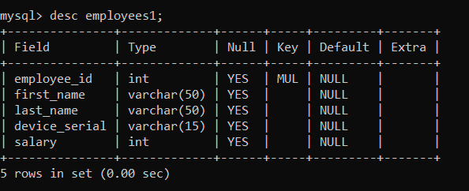
EXPERIMENT 10: Simple programming exercise using(REPEAT, WHILE )
CREATE DATABASE lab7;
USE lab7;
CREATE TABLE student(
SID INT,
SName VARCHAR(20),
Marks INT
);
INSERT INTO student VALUES
(1,'Ravi',85),
(2,'Kavya',92),
(3,'Manoj',76),
(4,'Sita',89);
SELECT * FROM student;
-- Subquery: Highest marks
SELECT SName, Marks
FROM student
WHERE Marks = (SELECT MAX(Marks) FROM student);
-- Correlated Query: Marks greater than overall average
SELECT S1.SName, S1.Marks
FROM student S1
WHERE S1.Marks > (
SELECT AVG(S2.Marks) FROM student S2
);

OUTPUT:
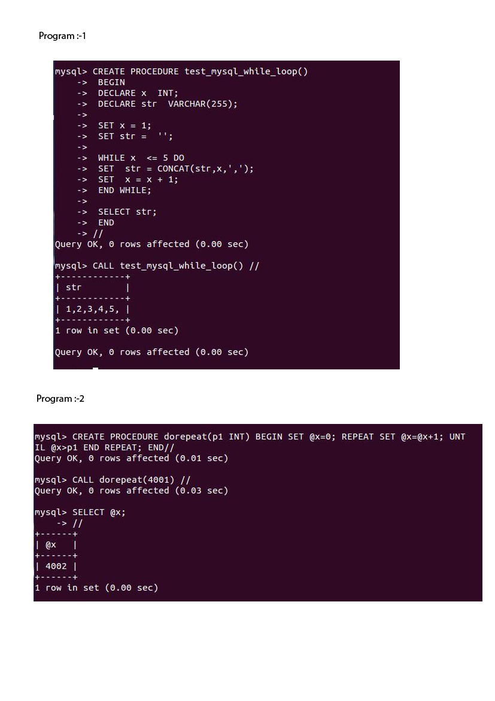

EXPERIMENT 11: Simple program exercise using(CASE and LOOP)

CREATE DATABASE lab7;
USE lab7;
CREATE TABLE student(
SID INT,
SName VARCHAR(20),
Marks INT
);
INSERT INTO student VALUES
(1,'Ravi',85),
(2,'Kavya',92),
(3,'Manoj',76),
(4,'Sita',89);
SELECT * FROM student;
-- Subquery: Highest marks
SELECT SName, Marks
FROM student
WHERE Marks = (SELECT MAX(Marks) FROM student);
-- Correlated Query: Marks greater than overall average
SELECT S1.SName, S1.Marks
FROM student S1
WHERE S1.Marks > (
SELECT AVG(S2.Marks) FROM student S2
);

OUTPUT:
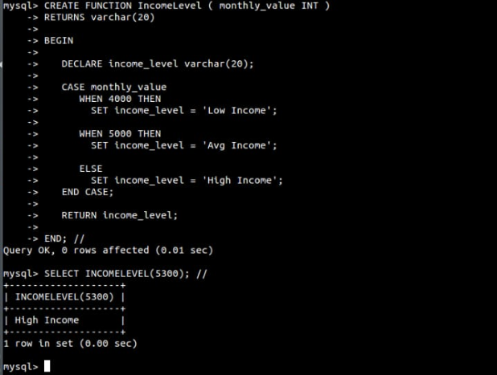

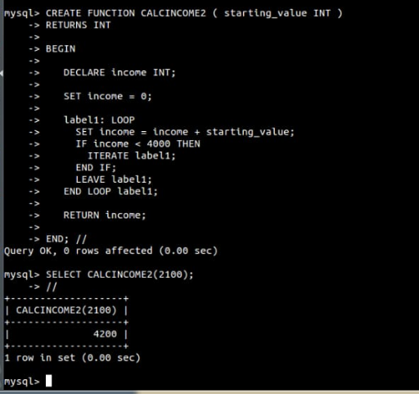
EXPERIMENT 12: TCL COMMANADS
CREATE DATABASE lab8;
USE lab8;
CREATE TABLE dept(
DeptNo INT,
DeptName VARCHAR(20)
);
INSERT INTO dept VALUES
(10,'CSE'),
(20,'ECE'),
(30,'EEE');
CREATE TABLE employee(
EmpNo INT,
EName VARCHAR(20),
DeptNo INT
);
INSERT INTO employee VALUES
(1,'Ravi',10),
(2,'Kavya',20),
(3,'Manoj',10),
(4,'Sita',40);
-- View all rows
SELECT * FROM dept;
SELECT* FROM employee;
-- Joins
SELECT e.EmpNo, e.EName, d.DeptName
FROM employee e, dept d
WHERE e.DeptNo = d.DeptNo;
SELECT e.EmpNo, e.EName, d.DeptName
FROM employee e
INNER JOIN dept d ON e.DeptNo = d.DeptNo;
SELECT e.EmpNo, e.EName, d.DeptName
FROM employee e
LEFT JOIN dept d ON e.DeptNo = d.DeptNo;
SELECT e.EmpNo, e.EName, d.DeptName
FROM employee e
RIGHT JOIN dept d ON e.DeptNo = d.DeptNo;
OUTPUT:
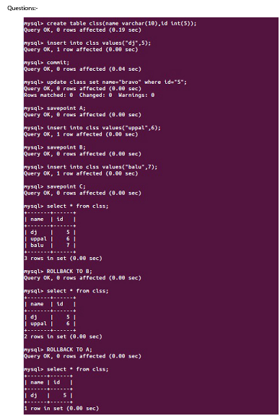
EXPERIMENT 13: DCL COMMANADS

CREATE DATABASE companyDB;
USE companyDB;
CREATE TABLE employees (
EmpID INT PRIMARY KEY,
EmpName VARCHAR(50),
DeptName VARCHAR(30),
Salary INT
);
INSERT INTO employees VALUES
(1, 'Ravi', 'IT', 50000),
(2, 'Kavya', 'IT', 60000),
(3, 'Arun', 'HR', 40000),
(4, 'Divya', 'HR', 45000),
(5, 'Sita', 'Finance', 70000),
(6, 'Raj', 'Finance', 80000),
(7, 'Mohan', 'IT', 55000);
-- 🔹 Subquery: Employees earning more than company average salary
SELECT EmpName, DeptName, Salary
FROM employees
WHERE Salary > (SELECT AVG(Salary) FROM employees);
-- 🔹 Correlated Subquery: Employees earning more than
-- the average salary of their own department
SELECT EmpName, DeptName, Salary
FROM employees e1
SELECT AVG(Salary)
FROM employees e2
WHERE e1.DeptName = e2.DeptName
);

EXPERIMENT 14: HIGH LEVEL PROGRAMMING EXTENSIONS (PROCEDURES
CREATE DATABASE lab7;
USE lab7;

CREATE TABLE student(
SID INT,
SName VARCHAR(20),
Marks INT
);

INSERT INTO student VALUES
(1,'Ravi',85),
(2,'Kavya',92),
(3,'Manoj',76),
(4,'Sita',89);

SELECT * FROM student;

-- Subquery: Highest marks
SELECT SName, Marks
FROM student
WHERE Marks = (SELECT MAX(Marks) FROM student);

-- Correlated Query: Marks greater than overall average
SELECT S1.SName, S1.Marks
FROM student S1
WHERE S1.Marks > (
SELECT AVG(S2.Marks) FROM student S2
);

OUTPUT:
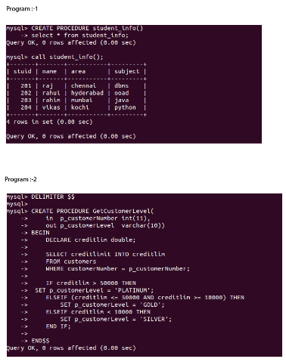

EXPERIMENT 15: HIGH LEVEL PROGRAMMING EXTENSIONS
(FUNCTIONS)

CREATE DATABASE lab8;
USE lab8;

CREATE TABLE dept(
DeptNo INT,
DeptName VARCHAR(20)
);
INSERT INTO dept VALUES
(10,'CSE'),
(20,'ECE'),
(30,'EEE');

CREATE TABLE employee(
EmpNo INT,
EName VARCHAR(20),
DeptNo INT
);
INSERT INTO employee VALUES
(1,'Ravi',10),
(2,'Kavya',20),
(3,'Manoj',10),
(4,'Sita',40);

-- View all rows
SELECT * FROM dept;
SELECT * FROM employee;

-- Joins
SELECT e.EmpNo, e.EName, d.DeptName
FROM employee e, dept d
WHERE e.DeptNo = d.DeptNo;

SELECT e.EmpNo, e.EName, d.DeptName
FROM employee e
INNER JOIN dept d ON e.DeptNo = d.DeptNo;

SELECT e.EmpNo, e.EName, d.DeptName
FROM employee e
LEFT JOIN dept d ON e.DeptNo = d.DeptNo;

SELECT e.EmpNo, e.EName, d.DeptName
FROM employee e
RIGHT JOIN dept d ON e.DeptNo = d.DeptNo;

OUTPUT:
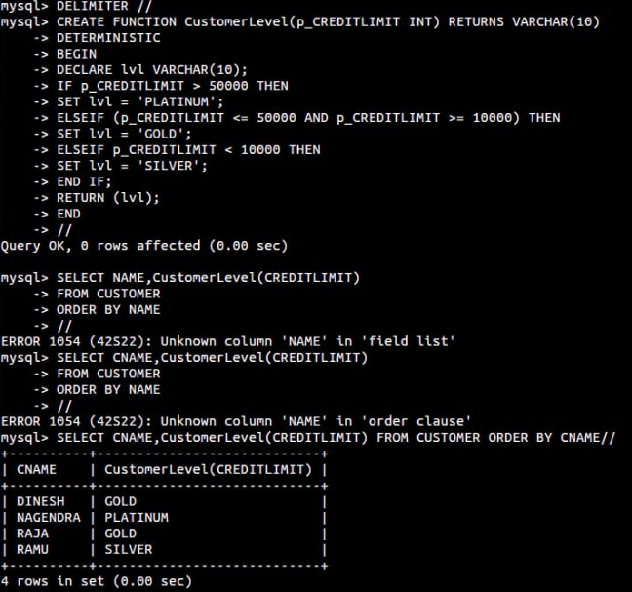

2)

EXPERIMENT 16: HIGH LEVEL LANGUAGE EXTENSION WITH CURSORS
-- Create a sample database
CREATE DATABASE companyDB;
USE companyDB;

-- Create an employees table
CREATE TABLE employees (
EmpID INT PRIMARY KEY,
EmpName VARCHAR(50),
DeptName VARCHAR(30),
Salary INT
);

-- Insert some sample records
INSERT INTO employees VALUES
(1, 'Ravi', 'IT', 50000),
(2, 'Kavya', 'IT', 60000),
(3, 'Arun', 'HR', 40000),
(4, 'Divya', 'HR', 45000),
(5, 'Sita', 'Finance', 70000),
(6, 'Raj', 'Finance', 80000),
(7, 'Mohan', 'IT', 55000);

-- Example 1: GROUP BY (average salary by department)
SELECT DeptName, AVG(Salary) AS Avg_Salary
FROM employees
GROUP BY DeptName;

-- Example 2: GROUP BY with HAVING (departments with average salary > 55000)
SELECT DeptName, AVG(Salary) AS Avg_Salary
FROM employees
GROUP BY DeptName
HAVING AVG(Salary) > 55000;

-- Example 3: GROUP BY + HAVING + ORDER BY (highest average salaries first)
SELECT DeptName, AVG(Salary) AS Avg_Salary
FROM employees
GROUP BY DeptName
HAVING AVG(Salary) > 45000
ORDER BY Avg_Salary DESC;

OUTPUT:
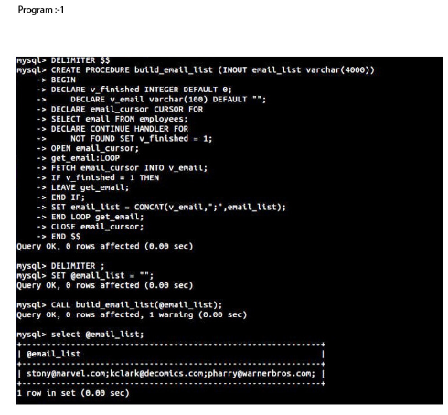
EXPERIMENT 17: TRIGGER
-- Create database and table
CREATE DATABASE companyDB;
USE companyDB;

CREATE TABLE employees (
EmpID INT PRIMARY KEY,
EmpName VARCHAR(50),
DeptName VARCHAR(30),
Salary INT
);

-- Insert sample data
INSERT INTO employees VALUES
(1, 'Ravi', 'IT', 50000),
(2, 'Kavya', 'IT', 60000),
(3, 'Arun', 'HR', 40000),
(4, 'Divya', 'HR', 45000),
(5, 'Sita', 'Finance', 70000),
(6, 'Raj', 'Finance', 80000),
(7, 'Mohan', 'IT', 55000);

-- 🔹 Subquery: Employees earning more than company average salary
SELECT EmpName, DeptName, Salary
FROM employees
WHERE Salary > (SELECT AVG(Salary) FROM employees);

-- 🔹 Correlated Subquery: Employees earning more than
-- the average salary of their own department
SELECT EmpName, DeptName, Salary
FROM employees e1
WHERE Salary > (
SELECT AVG(Salary)
FROM employees e2
WHERE e1.DeptName = e2.DeptName
);

OUTPUT:
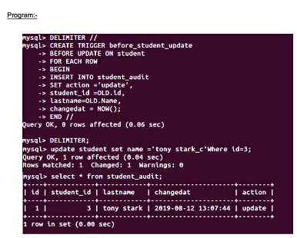

EXPERIMENT 18: SQL String Functions- REPLACE, REPEAT, RIGHT, RPAD
-- Drop old database if it already exists (prevents duplicate errors)
DROP DATABASE IF EXISTS companyDB;

-- Create fresh database
CREATE DATABASE companyDB;
USE companyDB;

-- Create Department table first (important for foreign key reference)
CREATE TABLE department (
DeptID INT PRIMARY KEY,
DeptName VARCHAR(30)
);

-- Create Employees table
CREATE TABLE employees (
EmpID INT PRIMARY KEY,
EmpName VARCHAR(50),
DeptID INT,
Salary INT,
FOREIGN KEY (DeptID) REFERENCES department(DeptID)
);

-- Insert Department data
INSERT INTO department (DeptID, DeptName) VALUES
(10, 'IT'),
(20, 'HR'),
(30, 'Finance'),
(40, 'Marketing');

-- Insert Employees data
INSERT INTO employees (EmpID, EmpName, DeptID, Salary) VALUES
(1, 'Ravi', 10, 50000),
(2, 'Kavya', 10, 60000),
(3, 'Arun', 20, 40000),
(4, 'Divya', 20, 45000),
(5, 'Sita', 30, 70000),
(6, 'Raj', 30, 80000),
(7, 'Mohan', 10, 55000);

-- ================================
-- 🔹 Equi Join
-- ================================
SELECT e.EmpName, e.Salary, d.DeptName
FROM employees e, department d
WHERE e.DeptID = d.DeptID;

-- 🔹 Inner Join
SELECT e.EmpName, e.Salary, d.DeptName
FROM employees e
INNER JOIN department d
ON e.DeptID = d.DeptID;

-- 🔹 Left Outer Join
SELECT e.EmpName, e.Salary, d.DeptName
FROM employees e
LEFT JOIN department d
ON e.DeptID = d.DeptID;

-- 🔹 Right Outer Join
SELECT e.EmpName, e.Salary, d.DeptName
FROM employees e
RIGHT JOIN department d
ON e.DeptID = d.DeptID;

OUTPUT:
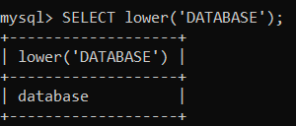

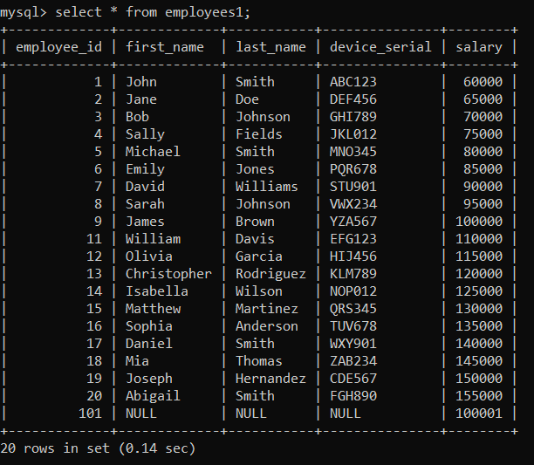

EXPERIMENT 19: DATABASECONNECTIVITYUSINGPHP AND MYSQL
-- Drop and create fresh database
DROP DATABASE IF EXISTS companyDB;
CREATE DATABASE companyDB;
USE companyDB;

-- Create Department table
CREATE TABLE department (
DeptID INT PRIMARY KEY,
DeptName VARCHAR(30)
);

-- Create Employees table
CREATE TABLE employees (
EmpID INT PRIMARY KEY,
EmpName VARCHAR(50),
DeptID INT,
Salary INT,
FOREIGN KEY (DeptID) REFERENCES department(DeptID)
);

-- Insert Departments
INSERT INTO department VALUES
(10, 'IT'),
(20, 'HR'),
(30, 'Finance'),
(40, 'Marketing');

-- Insert Employees
INSERT INTO employees VALUES
(1, 'Ravi', 10, 50000),
(2, 'Kavya', 10, 60000),
(3, 'Arun', 20, 40000),
(4, 'Divya', 20, 45000),
(5, 'Sita', 30, 70000),
(6, 'Raj', 30, 80000),
(7, 'Mohan', 10, 55000);

-- =========================
-- 🔹 Create VIEW + Use it
-- =========================
CREATE VIEW emp_dept_view AS
SELECT e.EmpID, e.EmpName, e.Salary, d.DeptName
FROM employees e
INNER JOIN department d ON e.DeptID = d.DeptID;

-- Query the view
SELECT * FROM emp_dept_view;

-- =========================
-- 🔹 Create INDEX + Use it
-- =========================
CREATE INDEX idx_salary ON employees(Salary);

-- Query that benefits from index
SELECT * FROM employees WHERE Salary > 60000;

OUTPUT:
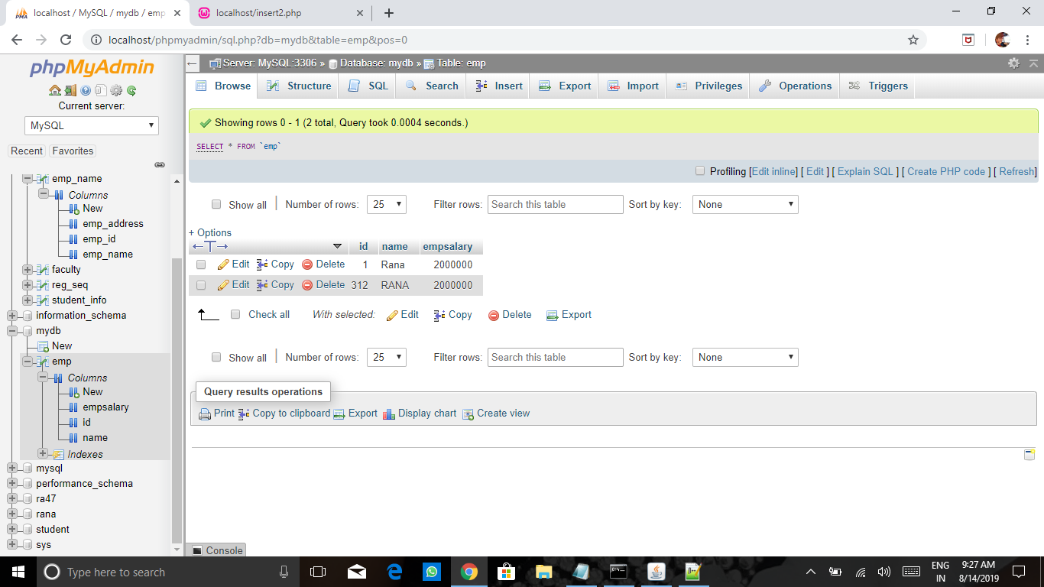
After deletion:
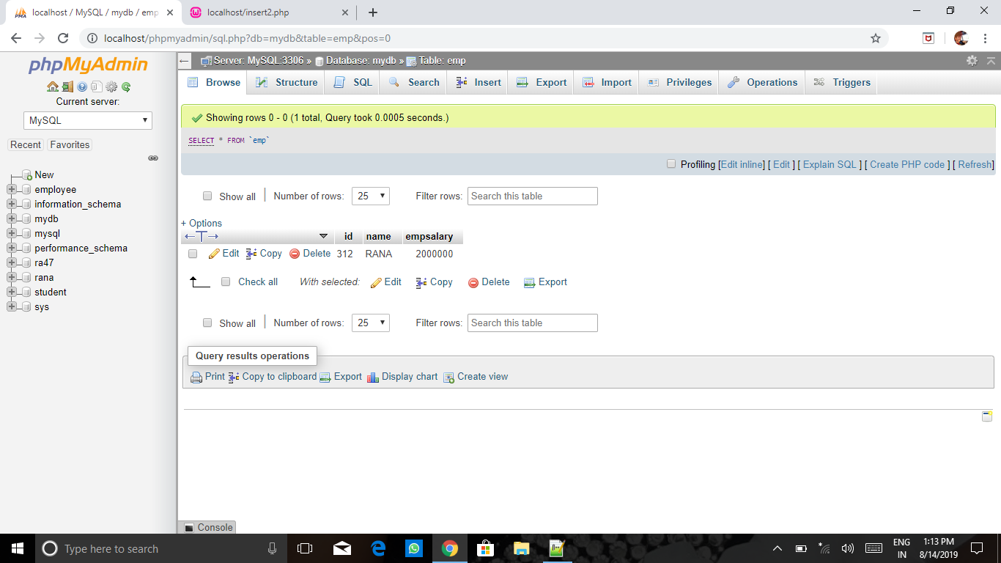
After updation:
